Heroes of Pymoli

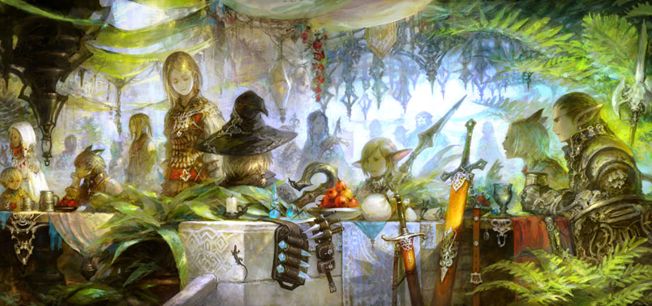

Luiz Celeste

# Observations

1. The majority of players are male (84%); however, females spend about 40 cents more per purchase than males do.
2. The vast majority of players fall within 15-29 years old. Age bracket 20-24 is responsible for nearly 50% of total purchase value.
3. User Lisosia93 spent the most amount of money ($18.96) purchasing items. Chamjask73 had the highest spending per purchase ($4.61).
4. The most purchased item was Oathbreaker, Last Hope of the Breaking Storm with 12 total purchases.